第二届“认证杯”数学中国
数学建模国际赛
承 诺 书

我们仔细阅读了第二届“认证杯”数学中国数学建模国际赛的竞赛规则。
我们完全明白，在竞赛开始后参赛队员不能以任何方式（包括电话、电子邮件、网上咨询等）与队外的任何人（包括指导教师）研究、讨论与赛题有关的问题。
我们知道，抄袭别人的成果是违反竞赛规则的, 如果引用别人的成果或其他公开的资料（包括网上查到的资料），必须按照规定的参考文献的表述方式在正文引用处和参考文献中明确列出。
我们郑重承诺，严格遵守竞赛规则，以保证竞赛的公正、公平性。如有违反竞赛规则的行为，我们将受到严肃处理。
我们允许数学中国网站(www.madio.net)公布论文，以供网友之间学习交流，数学中国网站以非商业目的的论文交流不需要提前取得我们的同意。
我们的参赛队号为：1290
我们选择的题目是：B题
参赛队员 (签名) ：
队员1：徐 亮

队员2：冯保进

队员3：邢 庆

参赛队教练员 (签名)： 无

第二届“认证杯”数学中国
数学建模国际赛
编 号 专 用 页

参赛队伍的参赛队号：（请各个参赛队提前填写好）：

1290

竞赛统一编号（由竞赛组委会送至评委团前编号）：

竞赛评阅编号（由竞赛评委团评阅前进行编号）：

Job Exchange Strategies and Analysis
Team # 1290
December 9, 2013
Abstract
In this paper, we built mathematic models based on deferred acceptance algorithm to evolve social strategies to exchange jobs in queue. We gave solutions and result analysis to the goals raised in the information sheet.
Firstly, we studied the queue and exchange process of the hermit. Then we analyzed the problems that how the exchange proceeded when a vacancy position appears in a firm. We modeled the exchange strategies of the hermit as the theory basic of our employment model.
Secondly, we built the basic job exchange model based on deferred acceptance algorithm by forming matching 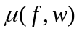between firm(f) and workers(w). The model can wonderfully simulate the queue and exchange process by the matching’s iteration.
Finally, we improved the employment model by introducing vacancy probabilities of each stratum, so that the model can be used to solve practical problem when a vacancy flowed in the firm. We analyzed the result of the model by running an actual case Then we built evaluation model which is related to the output of vacancy chain’s length and the total number of exchange.
Key words: Deferred acceptance algorithm；Vacancy chain Exchange；
Benefit Evaluation；

Contents
1. Introduction 6
1.1 Hermit crabs’ vacancy chain 6
1.2 Inspiration on employment pattern of human 7
1.3 Problems in applying “vacancy chain” into human resource market. 7
1.4 Deferred acceptance algorithm 7
2. The Description of the Problem 7
2.1 How does an empty position appear? 7
2.2 How does a man get the order to obtain a new job? 7
2.3 what is the exchange strategy? 8
2.4 What if there is no data available? 8
3. Models 8
3.1 Hermit crabs’ distribution model 8
3.1.1 Hermit queue Model 8
3.1.2 Shell exchange Model 8
3.2 Job exchange basic Model 9
3.2.1 Assumptions and Definitions 9
3.2.2 The Foundation of Model 10
3.3 Improved employment Model 11
3.3.1 Assumptions and definitions 11
3.3.2 The Foundation of Model 12
3.3.3 Applications of the model 12
3.4 Solution and Result of goal one 15
3.4.1 Solution of goal one 15
3.4.2 Result analysis of goal one 16
3.5 Solution and Result of goal two 17
3.5.1 Solution of goal two 17
3.5.2 Result analysis of goal two 18
3.6 Strength and Weakness 19
3.6.1 Strength 19
3.6.2 Weakness 19
4. Conclusions 19
4.1 Conclusions of the problem 19
4.2 Methods used in our models 20
4.3 Applications of our models 20
5. Future Work 20
6. References 21
7. Appendix 22
8. Advertising sheet 23

1. Introduction
In order to indicate the origin of job exchange problems, the following background is worth mentioning.

1.1 Hermit crabs’ vacancy chain
Hermit crabs depend on other creatures' shells for protection. When a lone crab encountered one of the beautiful new shells, it immediately inspected the shelter with its legs and antennae and scooted out of its current home to try on the new shelter for size. If the new shell was a good fit, the crab claimed it.
However, the new shell may not be fit for the crab. If it was too big, the crab did not scuttle away disappointed—instead, it stood by its discovery for anywhere. Eventually other crabs showed up, each one trying on the shell. If the shell was also too big for the newcomers, they hung around too. The crabs did not gather in a random arrangement, however. Rather, they clamped onto one another in a conga line stretching from the largest to smallest animal—a behavior the biologists dubbed "piggybacking" shown in the Fig. 1- 1.
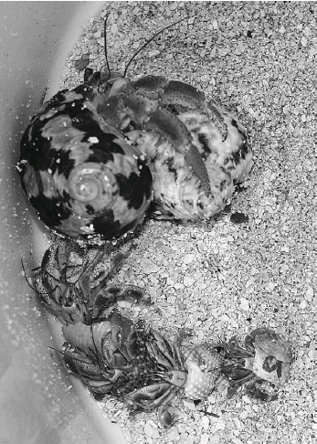
Fig. 1- 1 hermit crabs’ queue
As soon as a crab claimed its new home, all the crabs in queue swiftly exchanged shells in sequence. The largest crab at the front of the line seized the crab's abandoned shell. The second largest crab stole into the first's old shell. And so on.

1.2 Inspiration on employment pattern of human
Sociologists and economists use the term “vacancy chain” to describe a sequential exchange of resources that benefits every individual in the sequence. vacancy chains are an excellent way to distribute resources: Unlike more typical competition, a single vacancy chain benefits everyone involved—each individual gets an upgrade. So it makes sense that hermit crabs have evolved sophisticated social behaviors to make the most of vacancy chains. Studying how these animals behave may help us improve how we distribute resources—such as jobs.
This paper mainly studies hermit crabs’ behaviour pattern, and then matches it with the employment pattern of human.

1.3 Problems in applying “vacancy chain” into human resource market.
1) Queue problem: When the hermits are waiting to fit the new shell, they get into a queue by the size of them. How do human get the order to get a new job when the position is empty, on matter it is caused by incumbent’s retirement or new position’s creation.
2) Distribution problem: When a hermit get the new shell, the follower will get the shell abandoned by the ahead one. How do human get the empty position left by the leaving incumbent until all jobs are filled.

1.4 Deferred acceptance algorithm
This paper uses the deferred acceptance algorithm to build the basic model and improved it by introducing probabilities of each stratum in the firm. Then we analyzed the result of an actual case and finally we evaluated the model.

2. The Description of the Problem

2.1 How does an empty position appear?
In the hermit case, exchange is begun by a discovery of a new shell. If the logic apply to the resource distribution, such as jobs, we give the ways in which an empty position appear:
- First empty position is caused by the retirement or creation of a new job.
- As the worker fill a new position, his former position is empty.
- Exchange proceeds until all positions in system are filled.

2.2 How does a man get the order to obtain a new job?
In the hermit case, they queue according to their size. But in the HR case, how the queue form is determined by both employers and applicants.
1) From the perspective of employers:
Employers want to hire an employee who fit for the empty position most. Several element can be considered as reference such as work experience, age, familiar with the new job or not. That is, whether an employee can get the job is depended on the preference of the employer to the employee. So when an empty position faces several applicants, the employer will queue them by firm’s preference of that empty position.
2) From the perspective of applicants:
We consider the HR market is free for both employer and employee. The applicants formed the queue by the rules talked above automatically once he send the application. As long as an applicant is accepted, he benefits from the vacancy chain. Even if he is not accepted, there is no harm to him.
Conclusion: In the HR market, firm(employer) is the main element how a queue is formed by its’ preference to the applicants.

2.3 what is the exchange strategy?
When an empty position appears (how does it appear refers to 2.1), the applicants will be queued by the employer according to the preference of the position to the applicants. And the position will be filled by the people A who holds the biggest preference of the position. Then the former position of A is now empty, who will be filled in this position is as well depended by this position’s preference to its’ applicants. The market get a circulation as above until all positions are filled.

2.4 What if there is no data available?
In an HR market, empty positions are generated randomly, number of applicants to a position is relatively disperse. So we can survey the data from some HR websites or documents that government released.
If there is no data available, we can generate data by the means of frequently-used probability distribution function, such as normal distribution, Poisson distribution.

3. Models

3.1 Hermit crabs’ distribution model

3.1.1 Hermit queue Model
As is described above, the hermit is queued by their size, so the rule is as:
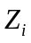>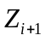 i=1,2…N (3-1)
Z_{i} represents the size of the hermit of No.i.

3.1.2 Shell exchange Model
When a hermit get the new shell, the following hermit will get the abandoned shell by turn until the last one. So we get the basic model for the exchange strategy.
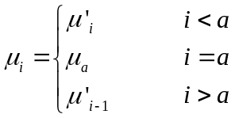 (3-2)
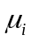 represents the shell of the ith hermit in the system after exchange. 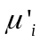 represents the shell of the ith hermit in the system before exchange, a is the numerical order of a hermit when the exchange begins.
This basic model refers to deferred acceptance algorithm, with which the system can get a relatively more rational and beneficial result of matching.

3.2 Job exchange basic Model
As is mentioned above, this paper builds the basic model by applying of deferred acceptance algorithm.

3.2.1 Assumptions and Definitions
Assumptions
We suppose following assumptions in the basic model:
1) All the changes of the position are occurred inner a firm.
2) In view of the fact, high level worker is not permitted to offer a lower level position.
3) whether a applicant is accepted or not is depended on the preference of the empty position.
Definitions
We give definitions in this paper as shown in Table 3-1:
Table 3-1 Definitions
symbol | Descriptions
F | finite sets of firms in a human resource market
W | finite sets of workers in a human resource market
f | Individual of F, fF
w | Individual of W, wW
V | V=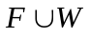
v | Individual of V, vV
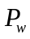 | a strict preference relation over the set
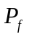 | a strict preference relation 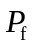over the set 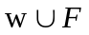
 | a one-to-one correspondence(FW) or(WF)

3.2.2 The Foundation of Model
A matchingis identified with a one-to-one correspondence: VV, where( f )= w and (w)= f, if( f, w), and(v)= v if no pair incontains v. Given a matching, we call(v) the outcome for v under. If(v)v we say that v is matched under and call(v) the mate of v under. We say that v is unmatched under if(v)= v.
We study executions of the Deferred Acceptance (DA) Algorithm with arbitrary input matching. We show that each such execution is finite and that all executions with the same input yield a common output matching; we further characterize the output in terms of the input matching and the players' preferences. Given an unstable matching 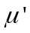with a blocking pair ( f, w) we say that the matching is obtained from by satisfying the blocking pair ( f, w) if f and w are matched to each other in, their mates (if any) inare unmatched in, and the outcomes for all other agents remain unchanged. A firm and a worker who each prefer the other to their outcome under the given matching, this is called blocking-pair.
So the model is:
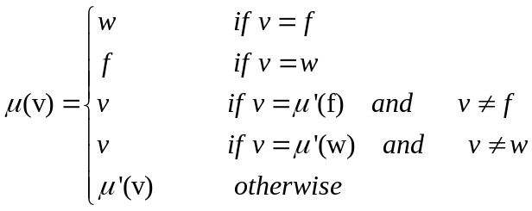 (3-3)
Description of the model:
1) 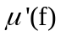w,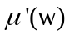f, ( f, w) is a blocking-pair. That means both f and w prefer each other than the outcomes in the matching .
2) ( f )= w and(w)= f. That means in the new matching , both f and w are satisfied by the exchange of v (f or w).
3) When the w (or f) is matched with f (or w) in , the former mate of w (or f) in is left, we consider (f) (or (w))is unmatched in .
4) The other matching except ((w) ,w) and (f,(f)) are still matched in .
5) (w) or (f) is left in result of the former exchange. To make the system stable, a new iteration is begun.
Based on the analysis above, we design our simulation arithmetic as Appendix A.
Of course, if is a matching, defined above is a matching as well. The job exchange strategies are shown as figure 3-1.
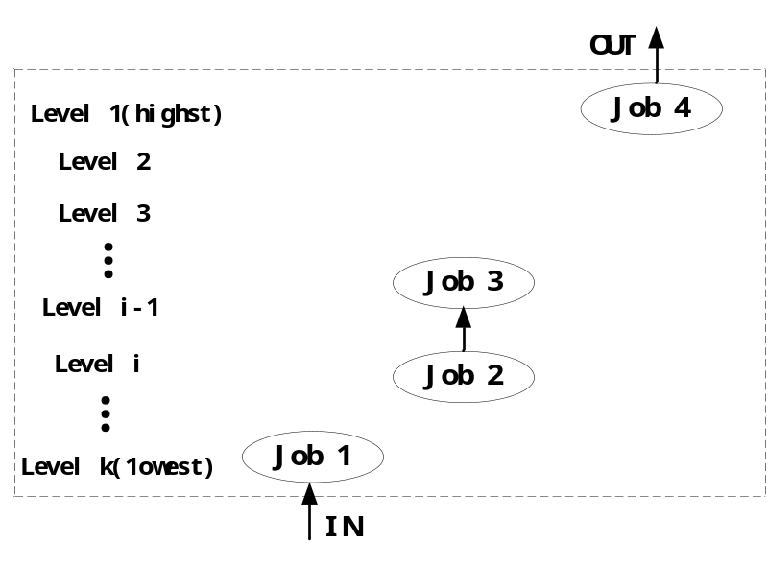
Fig 3-1 Resource exchange strategy
As noted earlier, and in the view of the fact, blocking-pair is caused by firm vacancy. It seeks to fill it by offering the vacant position to the worker it prefers most. We call this blocking-pair as firm-maximal blocking-pair. The blocking-pairs in this paper are all firm-maximal blocking-pairs. It means we consider that vacancy chain is created by a firm’s demand in a position.

3.3 Improved employment Model
Just not like the basic model, it is not the end after the exchange iteration. We should consider the model application in a practical occasion. So we make the input and output of the model visible by the quantification of firm’s structure. The structure consists of firm hierarchy, number of workers in each hierarchy, and the probabilities of creating vacancies in each stratum.

3.3.1 Assumptions and definitions
Assumptions:
1) From a vacancy appears to the stability of the firm(system), The structure and the number of workers stay the same.
2) A vacancy can only move one stratum lower at each step.
3) If the vacancy is not at the lowest hierarchy, the turnover of the employment is inner the firm. Or ,the vacancy will be filled by the outside the firm.
4) In view of different structure of a firm, we assume that the vacancies are created at a certain time at a year, and they are filled in a very short time.
Definitions:
Parameters used in the model are defined as Table 3-2.
Table 3-2 Definition
Symbol | Descriptions
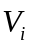 | Number of vacancies generated in ith stratum
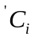 | Number of workers in ith stratum
N | Number of stratums
 | The number of vacancies in the ith stratum
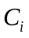 | The worker number of the ith stratum
S | Number of the applicants from outside the company
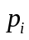 | The probability of creating vacancies in the ith stratum

3.3.2 The Foundation of Model
We introduce probability distribution to the generation of vacancies in each stratum. According to the assumptions above, we build the improved model as follow:
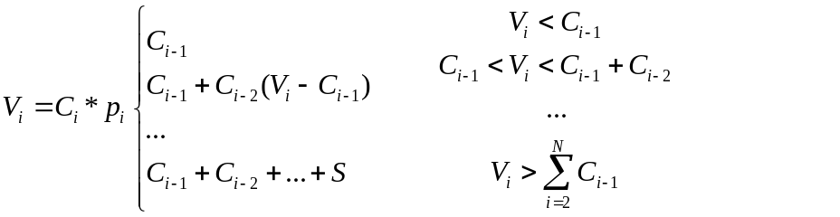 (3-4)
The flow chart of the model is as below:
Input of the model: vacancies in accordance with normal distribution.
Output of the model: the mean length of vacancy chains, the total length of the vacancy chains, the total expense.
How was the arithmetic realized is shown in Appendix B.

3.3.3 Applications of the model
We consider the number of ith stratum follows the function of 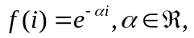 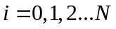, as the figure shows below. How was it realized is shown in Appendix C. Also we consider the creating probabilities of vacancies follows 1/2 normal distribution as figure 3-4 shows.
Assumed there are 1000 people in a firm, we can get information shown in table 3-3 and 3-4.

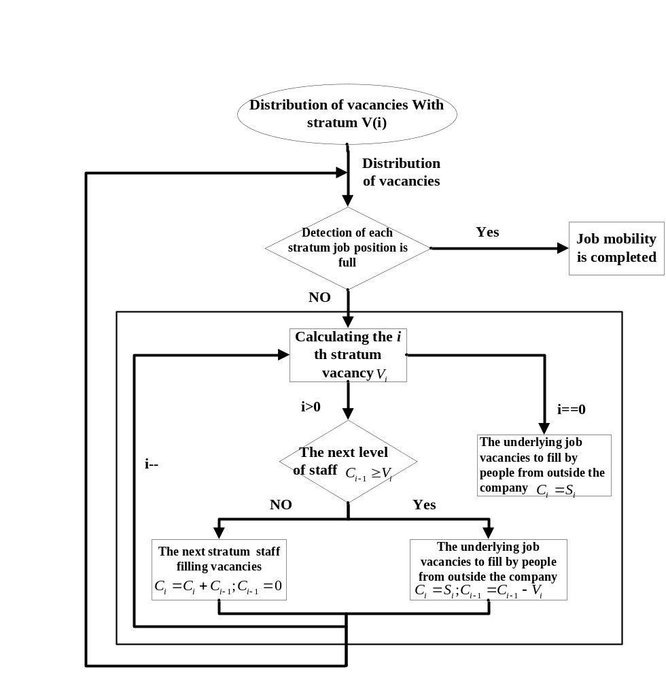
Fig 3-2 Flow chart of Improved employment Model

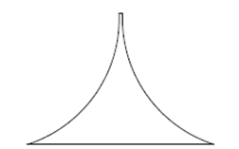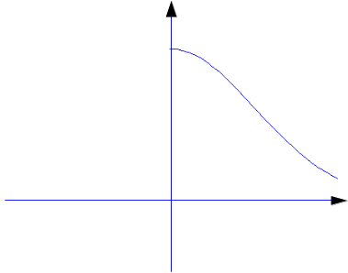
Fig 3-3 Stucture of a firm Fig 3-4 1/2 normal distrabution of p_{i}
Table 3-3 under function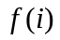
Stratum(i)
5 | 12
4 | 32
3 | 86
2 | 234
1 | 636
Table 3-4 V_{i} under normal distribution of
Stratum(i)
5 | 1
4 | 2
3 | 14
2 | 74
1 | 287

The firm complete the job exchange by 4 step iteration as shown in figure 3-5.
Figure 3-6 shows vacancy chain distribution of different length, it reflects p_{i} generated under probability distribution.

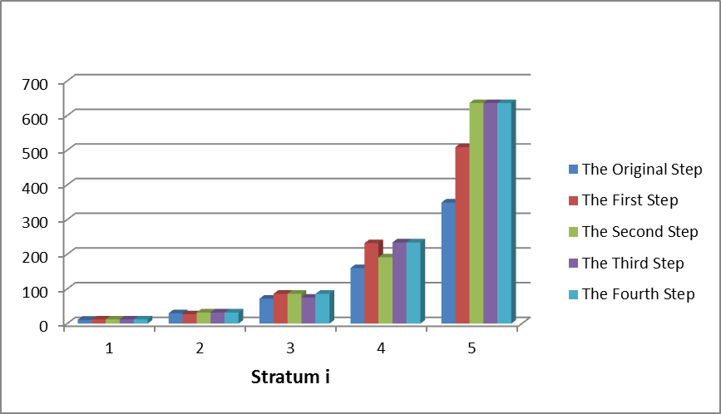
Fig 3-5 Change of by iterating
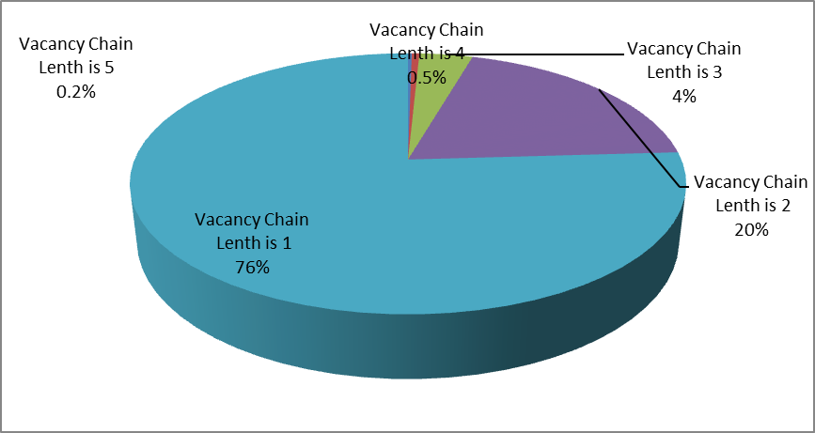
Fig 3-6 vacancy chain distribution of different length

3.4 Solution and Result of goal one

3.4.1 Solution of goal one
As the result of our model shows in section 3.3, the mean length of the chain caused by a vacancy and the total length of the chain can be obtained.
Signs and definitions indicated above are still valid. Here are some extra signs and definitions.
Table 3-5
Symbol | Description
 | The chain length of the vacancy created in the ith stratum
L | The total number of the job exchange
Q | The complexity of employment exchange
Can we apply the strategies to all industries?
L is the total number of the job exchange, and it is calculated as follows:
L= 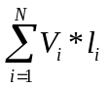 (3-5)
L is an important parameter to analyze the application of the model:
1) L can be considered as the scale that benefit from the job exchange, because every exchange represent a promotion. A bigger L is good in this way.
2) L can be seen as workload for an HR manager, because every exchange represents a work to train the new comer. A bigger L is bad in this way.
As is shown in “A Model of Vacancy Chains as a Mechanism for Resource Allocation” by Guido Fioretti, we can classify different industries into 3 kinds. They are Hierarchy(a), Inverted Hierarchy (b), and Linear(c) as shown below.
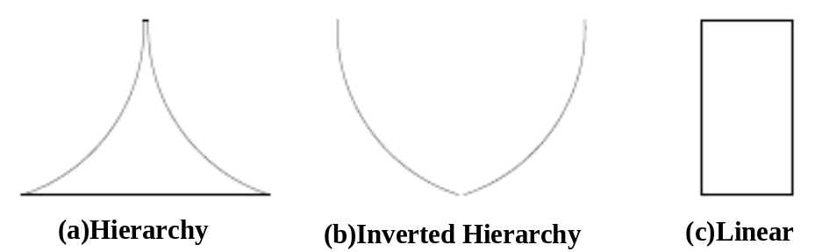
Fig 3-6
Assumed that the total number of the employees of these firms is the same. We calculated L by different structures under 3 kinds of probabilities distribution shown as figure???.
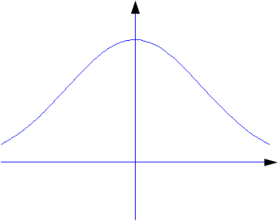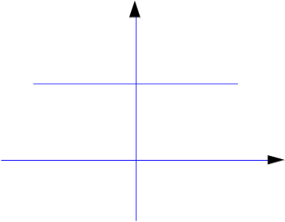
Fig 3-7 Three kinds of probabilities distribution used in L

3.4.2 Result analysis of goal one
L calculated by different structures under 3 kinds of probabilities distribution is shown in figure 3-8.
As is written above, L has a different understanding according to your evaluation methodology. Of course, L is changed under different probability distribution. Firm in structure a and c under normal and constant destitution can benefit more employees. At the same time, firms in structure a under normal distribution get the lower workload wen job vacancies appear.
As the analysis above, we can not apply it to all industries. The condition that need to meet are as follows:
1) The resource units are reusable, discrete, identifiable and utilized by one individual or social group at a time.
2) A unit must be vacant before it can be taken by a new occupant;
3) Individuals must need or want new and usually .bigger. or .better. units;
4) Most individuals in a group already must have units so they can leave one behind when they move to a new one.
5) What is the more important factor to manage the HR, increasing employees’ positivity, or reducing the workload caused by job exchange.
In conclusion: In the case of the distribution of job resource , our model runs under the condition that firms have a larger influence on the flow of vacancy chains in allocating scarce resources, and hierarchical organization forms with less senior level managers are more likely to benifit from this vacancy chains model.
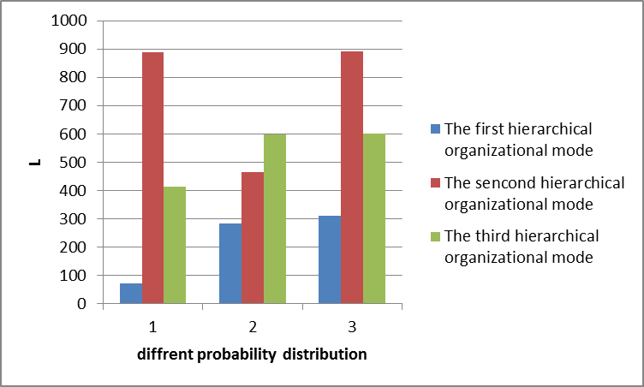
Fig 3-8

3.5 Solution and Result of goal two

3.5.1 Solution of goal two
Signs and definitions indicated above are still valid. Here are some extra signs and definitions.
Table 3-6
Symbol | Description
m | The number of job applicants
H | Expense of HR for enterprise customers
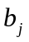 | Uncertainty factor of the employment in the jth year
 | The expense that cost for the chain of length which is caused by the vacancy of the ith stratum
y | Running year of the HR website
1) How many job applicants do need to satisfy both employers and employees ?
Since every chain is ended by the fill from outside the firm, so we consider this fill as an applicant, that means each chain represents an applicant outside the firm. As is defined in section 3.3, S_{i} is considered as the number of the applicants who are going to satisfy both employer and employee to get the system into stability.
The number of job applicants, m is expressed as:
m=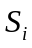=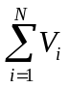 (3-6)
2) Prediction of the change of HR expends for some enterprise customers within the next five years.
The expense of HR caused by employment exchange in 1 year is:
h=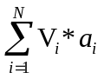 (3-7)
We consider the uncertainty of the employment in different years as a uncertainty factor , .
The expense of HR caused by employment exchange in 5 years is expressed as :
H=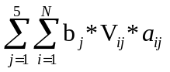 (3-8)
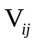is the number of vacancies in the ith stratum of the jth year. Also, 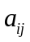is the expense that cost for the chain of length which is caused by the vacancy of the ith stratum of the jth year.

3.5.2 Result analysis of goal two
We use the data calculated above.
Table 3-7 number of job vacancies in ith stratum
Stratum i
5 | 1
4 | 2
3 | 14
2 | 74
1 | 287
The expense that cost for the chain of length which is caused by the vacancy of the ith stratum is given as follows:
Table 3-8 The expense that cost for the chain of length
Stratum i | (yuan)
4->5 | 8000
3->4 | 4000
2->3 | 2000
1->2 | 1500
0->1 | 1200
is a set of random numbers whose mean number is 1. We give them as follows:
Table 3-9 Uncertainty factor of the employment in the jth year
b | 0.9831 | 1.0011 | 0.9991 | 0.9911 | 1.0074

So , we get the expense of HR for enterprise customers as :
H=2497 (thousand yuan)
Of course, H will be changed by the parameters shown in the formula, and what we get has a reference significance for HR manager when running job exchange.
Other information is shown in the Table 3-10.
Table 3-10 Other information
Total length of the chains | Total number of the chains | Mean length of the chains
490 | 378 | 1.2963

3.6 Strength and Weakness

3.6.1 Strength
1) The model wonderfully simulates the process in which the hermit crabs exchange their shells.
2) The model is suitable for any creating procession of vacancy position, such as Poisson distribution and normal distribution.
3) The model can get accurate result of the vacancy chain flow and the change of HR expense for the position exchange in a firm.
4) The model has a guiding significance in HR management when the system goes to the stability from the appearance of a vacancy position.

3.6.2 Weakness
The application of this model to a labor market (not like a firm ) is not good enough because of the assumptions that vacancies can only flow from higher level to the lower one and that the structure of the system stays the same. This has doomed to limit the applications of it.

4. Conclusions

4.1 Conclusions of the problem
- Queue problem: When an empty position appears, we build a firm-maximal blocking-pair, and as the iteration goes on, new firm-maximal blocking-pair is generated by the judgment of the preference of the firm. So we can get a queue of the applicants just like the hermit crabs’ queue generated by their size.
- Exchange problem: In our model, workers are free to decide whether to send a application to a new position. So, if the worker who sends an application is permitted to get the new job, he benefits, at the same time, creates a new position for other people to be promoted. Of course, firm choose an applicant who meets its’ most preference, so the firm is satisfied, too.
- Application problem: Our basic model gives some assumptions by which the iteration goes on in a closed system. Due to its’ limitation of application, we improved the model so that it can be used to prediction an open system in which vacancy chains are flowing.
- Expense problem: In our improved model, we calculated the change of HR expends for some enterprise customers, and it has a guiding significance in HR management.
So , we significantly solve the problems raised in the subject of this CAMCM.

4.2 Methods used in our models
- In basic model, we mainly use the method of Deferred Acceptance (DA) Algorithm. As long as there is an position is empty, the model runs to get the system(market) into a stable condition by the iteration of matching in this method.
- In improved model, we used decreasing exponential function to generate the number of the ith stratum workers and used 3 kinds of probability distribution function to generate number of ith stratum vacancies.

4.3 Applications of our models
- This paper mainly studies ‘vacancy chain’, and its’ application into job exchange. Of course, the model can be used into social resource such as housing, cars‘ distribution.
- The model can be used as an reform solution of the college entrance examination enrollment system.
- Of course, in ordinary social life, vacancy chains can make firms and employees benefit from the creation of a vacancy position. But in some occasions, it may cause harm to the society. For example, According to the study of drug selling, when the policearrested the upstream of drug traffickers, this can create a long vacancy chains inadvertently, and make more people promoted in the illegal organization.

5. Future Work
As is mentioned above, though the model we established in this paper wonderfully simulate the process in which the hermit crabs exchange their shells, it is fitter for a relatively small-scale market or a certain enterprise. If we want the model to fit for a huge market, we should let go of the constraints and introduce more parameters which decides whether employee and employer are both satisfied.
Of course, other models are worth trying. For example, Firm-quasi-stability model, first introduced by Sotomayor, it works when stable matching are disrupted by the creation of new positions or by the retirement of existing workers.

6. References
- Yosef Blum, Alvin E. Roth, Uriel G. Rothblum. Vacancy Chains and Equilibration
in Senior-Level Labor Markets. journal of economic theory 76, 362 411 (1997).
- Shelby Stewman.An application of job vacancy chain model to a civil service internal labor market. The Journal of Mathematical Sociology.
- Joseph Persky, Daniel Felsenstein.Job Vacancy Chains and Local Employment
Creation: The Case of Supply-Side Restrictions.
[4] Joseph Persky, Daniel Felsenstein, Virginia Carlson.Job Vacancy Chains in
Metropolitan Labor Markets. 42nd European Congress of the Regional Science
Association, Dortmund, Germany,August 27-31, 2002.
[5] Guido Fioretti.A Model of Vacancy Chains as a Mechanism for Resource Allocation.2006.11.
[6] D. RANDALL SMITH.MOBILITY IN PROFESSIONAL OCCUPATIONAL INTERNAL LABOR MARKETS: STRATIFICATION, SEGMENTATION AND VACANCY CHAINS. American Sociological Review, Vol. 48, No. 3 (Jun., 1983), pp. 289-305.
[7] Ivan D. Chase. VACANCY CHAINS.Annual Review of Sociology, Vol. 17 (1991), pp. 133-154.
[8] William C. Wheaton. Vacancy, Search, and Prices in a Housing Market Matching Model. Journal of Political Economy, Vol. 98, No. 6 (Dec., 1990), pp. 1270-1292.
[9] H. J. SCHOLTEN, P. HOOIMEIJER.THE USE OF VACANCY CHAINS AND LOGLINEAR MODELS TO ANALYSE RELATIONSHIPS AMONG HOUSING SUB-MARKETS.
[10] Edward T. Ferrari. Geospatial Issues in the Construction of a ‘Vacancy Chain’ Model of a Housing Market. 5th AGILE Conference on Geographic Information Science, Palma (Balearic Islands, Spain) April 25th -27th ,2002.
[11] Gary Sands. A vacancy transfer model of the structure of the local housing
market. AREUEA JOURNAL.
[12] Randi D. Rotjan, Jeffrey R. Chabot, Sara M. Lewis. Social context of shell acquisition in Coenobita clypeatus hermit crabs. Behavioral Ecology.
[13] Ira S. Lowry . Filtering and Housing Standards: A Conceptual Analysis. Land Economics.
[14] Philip C. Emmi and Lena Magnusson. Further Evidence on the Accuracy of Residential Vacancy Chain Models. Urban Studies.
[15] ROMAN DZUS, GERALD ROMSA. HOUSING CONSTRUCTION, VACANCY CHAINS, AND RESIDENTIAL MOBILITY IN WINDSOR. CANADIAN GEOGRAPHER.

7. Appendix
A: Steps of Employment basic Model arithmetic
  - Step1: Input a matching, and preference array P.
  - Step2: Initialization: a. For all fF, 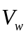(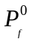)=()-(f)
b.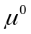=, i=1
  - Step3: If there is no fF such that 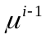 ( f )= f, stop with output .
  - Step4: Let f be a firm such that ( f )= f, and set w= 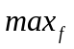().
  - Step5: If ( w )>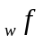, then 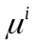=.
Else,
If ( w )= w, then =(f,w).
Else =(f,w)-(( w ),w)
  - Step6: (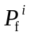)=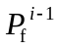-w, and for all 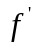, (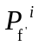)=(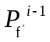).
  - Step7: i=i+1, Go To Step3.
B: Programs and codes of the improved model
int _tmain(int argc, _TCHAR* argv[])
{
int i = 0;
Vacancy vacancy_list;
Strata_DIs JobDis;

//CASE 1: given a particular vacancy，the vacancy chain flow process
Initialization_VacancyChain(&vacancy_list,&JobDis);
VacancyChainDynamic(&vacancy_list,&JobDis);
VacancyChainStatistics(&vacancy_list,&JobDis);

//Using the statistical distribution as the input
if(mode_style == 3)
{
for(i = 0;i<1000;i++)
{
Initialization_VacancyChain(&vacancy_list,&JobDis);
VacancyChainDynamic(&vacancy_list,&JobDis);
VacancyChainStatistics(&vacancy_list,&JobDis);
}
}
return 0;
}

This function is used to simulate the flow of companies after job vacancies:
void VacancyChainDynamic(Vacancy *vacancy_list,Strata_DIs *JobDis)
{
int i=0,j=0;
int Index_temp;
int StrataVacancy_Num;
int Num_fixedstate=0;
FILE *fp;

fp = fopen("test.txt","a");
fprintf(fp," Original allocation \n");
for(j = 0 ;j<JobDis->strata;j++)
{
fprintf(fp," %d ",JobDis->S_distrution_current[j]);
}
fprintf(fp," \n");
//Job vacancy distribution after removing
fprintf(fp,"Allocation After removing the space\n");
for(i=0;i<JobDis->strata;i++)
{
if( JobDis->S_distrution_fix[i] < vacancy_list->vacancy_num[i])
printf("Exceeds the maximum number of vacancies, unreasonable\n");
else
{
JobDis->S_distrution_current[i] = JobDis->S_distrution_fix[i] - vacancy_list->vacancy_num[i];
}
}
for(j = 0 ;j<JobDis->strata;j++)
{
fprintf(fp," %d ",JobDis->S_distrution_current[j]);
}
fprintf(fp," \n");
fprintf(fp," Sequential iteration start： \n");
while(Num_fixedstate < JobDis->strata)
{
Num_fixedstate = 0;
for(i=JobDis->strata-1;i>=0;i--)
{
StrataVacancy_Num=JobDis->S_distrution_fix[i]- JobDis->S_distrution_current[i];
if(StrataVacancy_Num!=0&&i!=0)
{
if(StrataVacancy_Num <= JobDis->S_distrution_current[i-1])
{
JobDis->S_distrution_current[i] = JobDis->S_distrution_fix[i];
JobDis->S_distrution_current[i-1]=JobDis->S_distrution_current[i-1] - StrataVacancy_Num;
}
else
{
JobDis->S_distrution_current[i]=JobDis->S_distrution_current[i]+ JobDis->S_distrution_current[i-1];
}
}
if(i==0)
{
JobDis->S_distrution_current[i] = JobDis->S_distrution_fix[i];
}
if(StrataVacancy_Num==0)
{
Num_fixedstate++;
}

for(j = 0 ;j<JobDis->strata;j++)
{
fprintf(fp," %d ",JobDis->S_distrution_current[j]);
}
fprintf(fp," \n");
}

if ( Num_fixedstate == JobDis->strata) break;

//Output for observation
for(j = 0 ;j<JobDis->strata;j++)
{
fprintf(fp," %d ",JobDis->S_distrution_current[j]);
}
fprintf(fp," \n");
}
fclose(fp);
}
C: Programs and codes of the decreasing exponent function f(i)
void Initialization_VacancyChain(Vacancy *vacancy_list,Strata_DIs *JobDis);
{
//User-defined
int strata = 5;

JobDis->S_distrution_fix = (int*) malloc(strata*sizeof(int));
JobDis->strata = strata;
FILE *fpS1,*fpS2,*fpS3,*fpS4,*fpS5;
if(mode_style == 1)
{
vacancy_list->vacancy_num = (int*) malloc(strata*sizeof(int));
vacancy_list->JobOccupation_Strata = (double*) malloc(strata*sizeof(double));
}
if(mode_style == 2)
{
JobDis->S_distrution_current = (int*) malloc(strata*sizeof(int));
vacancy_list->vacancy_num = (int*) malloc(strata*sizeof(int));
vacancy_list->JobOccupation_Strata = (double*) malloc(strata*sizeof(double));
}
if(mode_style == 3)
{
JobDis->S_distrution_current = (int*) malloc(strata*sizeof(int));

vacancy_list->vacancy_num = (int*) malloc(strata*sizeof(int));
vacancy_list->JobOccupation_Strata=(double*) malloc(strata*sizeof(double));
vacancy_list->SumExpend_JobOccupation = 0;
}

This function is to count chain length and other parameters of the vacancy flow process
void VacancyChainStatistics(Vacancy *vacancy_list,Strata_DIs *JobDis);
{
double mean_vacancychain_length = 0;
int sum_vacancychain_length = 0;
int num_vacancychain_length = 0;
int i;
FILE *fp;
fp = fopen("Vacancy Chain Statistics.txt","a");
for ( i =0 ;i<JobDis->strata;i++)
{
sum_vacancychain_length=vacancy_list->vacancy_num[i]*(i+1)+ sum_vacancychain_length;
}
for ( i =0 ;i<JobDis->strata;i++)
{
num_vacancychain_length=vacancy_list->vacancy_num[i]+ num_vacancychain_length;
}
for ( i =0 ;i<JobDis->strata;i++)
{
vacancy_list->SumExpend_JobOccupation= vacancy_list->vacancy_num[i]*(i+1)*vacancy_list->JobOccupation_Strata[i]+ vacancy_list->SumExpend_JobOccupation;
}
mean_vacancychain_length= (double)sum_vacancychain_length/num_vacancychain_length;
}




Our website apply deferred acceptance algorithm into the human resource exchange model. The DA algorithm runs when a job vacancy appears, and it always matches the position with the applicant whom it prefers most. By introducing probability distribution during model running, we can get the most important parameters which described the HR flowing, such as total exchange number, expense of job exchange and so on. So, this website is an occasion where both employers and employees are satisfied.
So just tell us your information and describe the job or the employee you want, our website will give you satisfying results.
Wish you good luck!

Dear employers and employees:
Welcome to the HR website. We are here to help you guys to combine a matching which is fit for you and your ideal mate most. Our creed is: employment is the means, Development is the goal!

